Logo%20Main%20200

**Boston University**

**Electrical & Computer Engineering**

**EC464 Capstone Senior Design Project**

User’s Manual

**Team 7: Cyborg Sax**

Submitted to

Zach Lasiuk

Arm

Address: 100 5th Avenue, Floor 5  
Waltham, MA, 02451

Phone: 715-781-5409

Email : lasiukza@bu.edu

Written by: Team 7 - CyborgSax

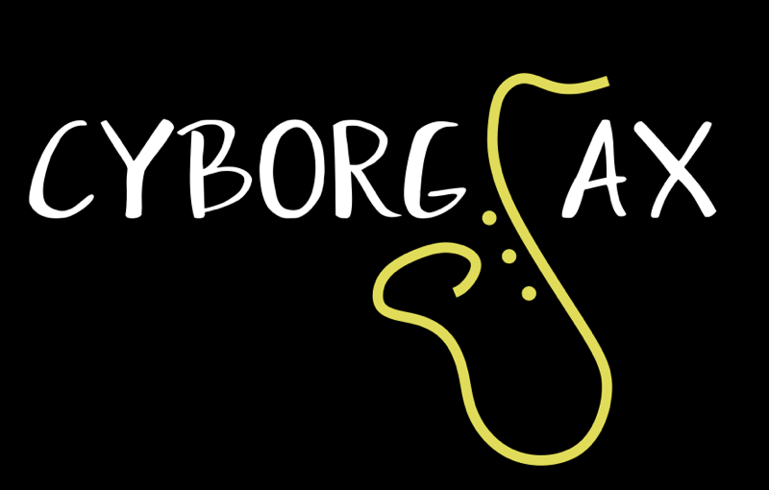

Team Members

Raymond Liang rliang6@bu.edu

Esiri Madagwa Jr. esiri558@bu.edu

Tariq Ahsan tahsan@bu.edu

Qinglang Yu yqlbu@bu.edu

Andrew Zannetos andrewzz@bu.edu

Submitted: April 11th, 2019

#### **Your Title**

#### **Table of Contents**

Executive Summary 3

1 Introduction 4

2 System Overview and Installation 6

2.1 Overview block diagram 6

2.2 User interface. 6

2.3 Physical description. 7

2.4 Installation, setup, and support 8

3 Operation of the Project 9

3.1 Operating Mode 1: Normal Operation 9

3.2 Operating Mode 2: Abnormal Operations 10

3.3 Safety Issues 10

4 Technical Background 11

5 Cost Breakdown 12

6 Appendices 13

6.1 Appendix A - Specifications 13

6.2 Appendix B – Team Information 14

# **Executive Summary**

CyborgSax

Team 7 – CyborgSax

There are currently no device available that can create both audio effects and visual effects for saxophonists. There are devices and systems for other instrumentalists such as pianists and guitarists that can accomplish these tasks, but not for saxophonists. Our client Zach, who plays the saxophone, wants to incorporate visual effects and audio effects into his live shows. The problem at hand is that there is no technology for saxophonists to have audio effects and eye-catching visual effects in their performances.

The team’s final deliverable will be an attachable device that can create audio effects and visual effects given a saxophone input, and then turn that into an sonic and visual output. The attachable device will take in a saxophone audio signal into the microphone which will be attached to the saxophone process the sound in real time and output some sort of modified signal through the speaker. Simultaneously, there will be visual lighting effects coming from the LED matrices that will be attached to the exterior of the saxophone. Both the visual effects and the audio effects will be controlled with a wearable device where there will be an LCD screen and a 2 rotary encoder knobs and a 4 position switch.

We implemented a microcontroller to process audio input from the saxophone and manipulate it using a library of audio effects controllable via the user interface, as well as utilizing the microcontroller’s built-in FFT functionality with LED matrices to create a visual display of the audio spectrum in real time.

**\**The main innovative feature behind this project are the user-controllable audio effects and the visual effects that were at previously unavailable to saxophonists.***

# **Introduction**

Our customer Zach Lasiuk wants to bring visual effects and audio effects into his live shows when he plays the saxophone. Without this attachable device, the shows that he plays at will not be as engaging and entertaining. Our customer has started this project himself as an individual project however has had problems getting the device to work. As a result he has requested our senior design team to help him design an attachable device that can create audio and visual effects as he plays the saxophone.

The entire attachable system will consist of a microprocessor, 2 LED matrices, a microphone and a controlling unit for controlling the visual effects and audio effects. Everything will be attached to the saxophone except for the controlling unit which will be attached to the saxophone player’s waist. A microphone will be attached to the front of the saxophone (the bell) where the SPL is maximized. The LED matrices and the microprocessor will be attached to the sides of the saxophone bell. The general way that the project system works is that there will be 2 scenarios where this system will be used. The first scenario is out on the streets for street performances, and the second scenario is for concert hall performances. For the street performances, an auxiliary out will be used to output the modified saxophone signal and sent to a portable powered speaker. The other case is at a concert venue, where the user output will be sent to the FOH mixer, where it will be outputted to the concert venue speakers.

The general purpose of our project is to give saxophonists a performance augmentation that many other type of musical performers have had for a long time. Vocalists, guitarists, and DJs are able to have live, on-stage light shows and real time audio effects, but this is not afforded to saxophonists, so our customer would like to bring this technology to the every-day saxophone player if they should choose to have a more “interesting” performance.

The way that our senior design team decided to approach the problem was to figure out what we wanted to do for the visual effects, as the audio effects are easily implemented into a Teensy microcontroller using the audio shield and audio design library. After some discussion, we believed that the best way to create visual effects was with LEDs - this is where we decided to use the LED matrix to display an accurate frequency spectrum analyser pattern from the saxophone input; we determined the LED matrix should be flexible so that it will fit nicely around the saxophone. When it comes to the audio effects, these can be programmed with an audio design lab, which creates a patchbay design to send audio signals through effects and then sent to the output via a line out port. All of the programming for the visual effects and audio effects will be done on a microprocessor.

Like an effect pedal for a guitarist, the product will provide digital audio effects to both alto and tenor saxophones, with the type of effect and its parameters controllable via a user interface controller attached to the user’s waist. The product will also analyze the audio input (which is connected to a microphone attached to the saxophone’s bell) and run it through an FFT algorithm to light up LED matrices in a manner that creates a visual equalizer/spectrum analyzer, as well as provide preset lighting patterns, for onlookers to enjoy.

Highlights of the project will include the ability for the system to have different kinds of audio effects and visual effects depending on what is selected on the controller. Instead of having just one visual effect or one audio effect, we will introduce a wearable controller that can give variety to performance effects for saxophonists. Another impressive feature of the project is for the system to have real time analysis with a latency for the visual effects to be about 100 milliseconds and audio latency of 10 milliseconds.

The remaining sections of the user’s manual will go over in detail the functionality of the product. These include instructions on using the controlling unit which has an LCD screen with 3 knobs to control settings. A detailed visual description will also be provided so the user can understand what each component is used for. There will also be explanations of the hardware and software behind the product.

# **2 System Overview and Installation**

## ***2.1 Overview block diagram***

Below is a control flow diagram which incorporates both the software and hardware of the system. The microphone receives a noise input which will then get fed into the Teensy audio shield. Once put into the audio shield, the input will go through a conversion from digital to analog. The converted audio signal will be processed by the Teensy. The Teensy will simultaneously do audio effects processing and LED pattern controlling. The controller can be used to alter how the LED displays its patterns and can also change the audio effects. The LED patterns then get transmitted to the 2 LED matrices. The sound also gets transmitted to the speakers.

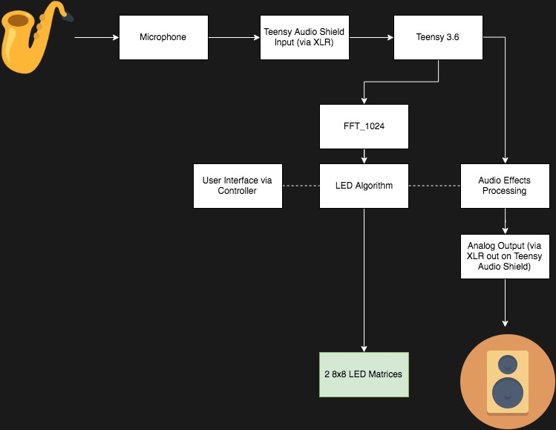

## ***2.2 User interface.***

Once the system is started, the welcoming screen of the controller will last for 4 seconds before going to the default page.

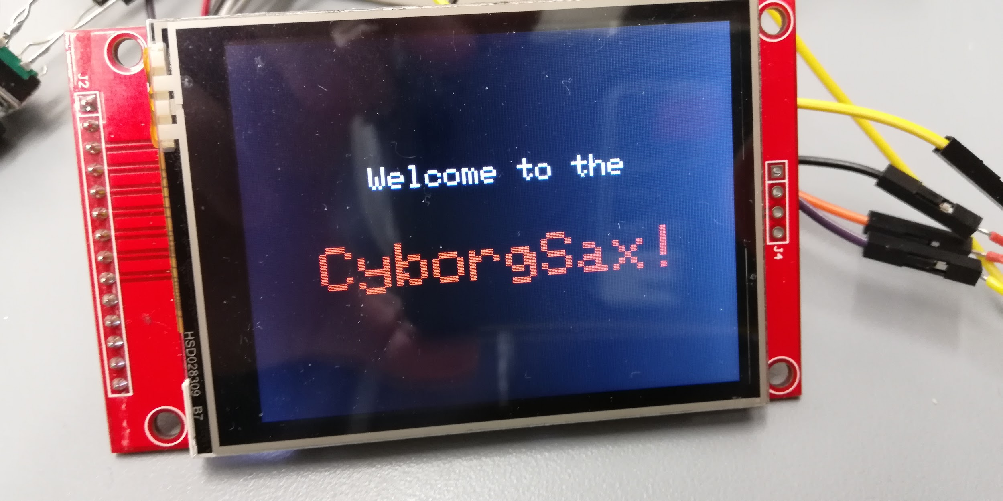

The photo below shows F1 and F2, two subsections of the user-selected mode. Parameters can be adjusted from the two encoder knobs. If the user wants to change the parameter value they need to push down the encoder until the F1 or F2 circle on the user interface turns red. After that the user can turn the knob to adjust the desired value of the parameter. For example if the user wants to adjust the Dry/Wet option the user must push down the second encoder,which will turn F2 red, and turn the knob clockwise to the desired percentage value. Once the desired value is selected the user can push down on the encoder knob to unselect F2. The modes can be switched with the 4 position switch which will change from sound, lighting, playback and general and there will be a change of the different F1 and F2 parameters for each different mode. The switch will be positioned to the default sound mode.

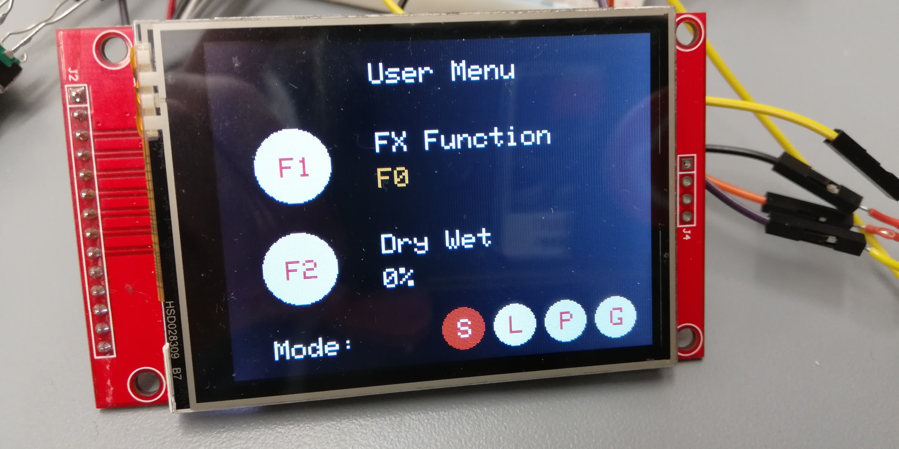

## ***2.3 Physical description.***

Below is a picture of the LCD screen with the 2 encoder knobs and a 4 position switch. These knobs and switches will be used to control the settings of the system.

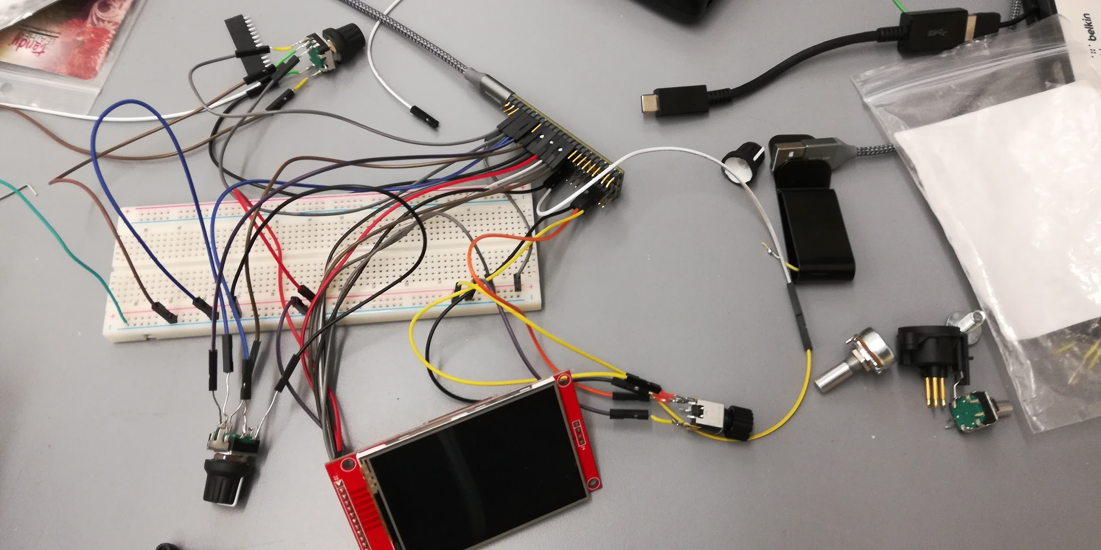

The LED matrix will be attached to the side of the saxophone with velcro. Next to the LED matrix is a microphone input.

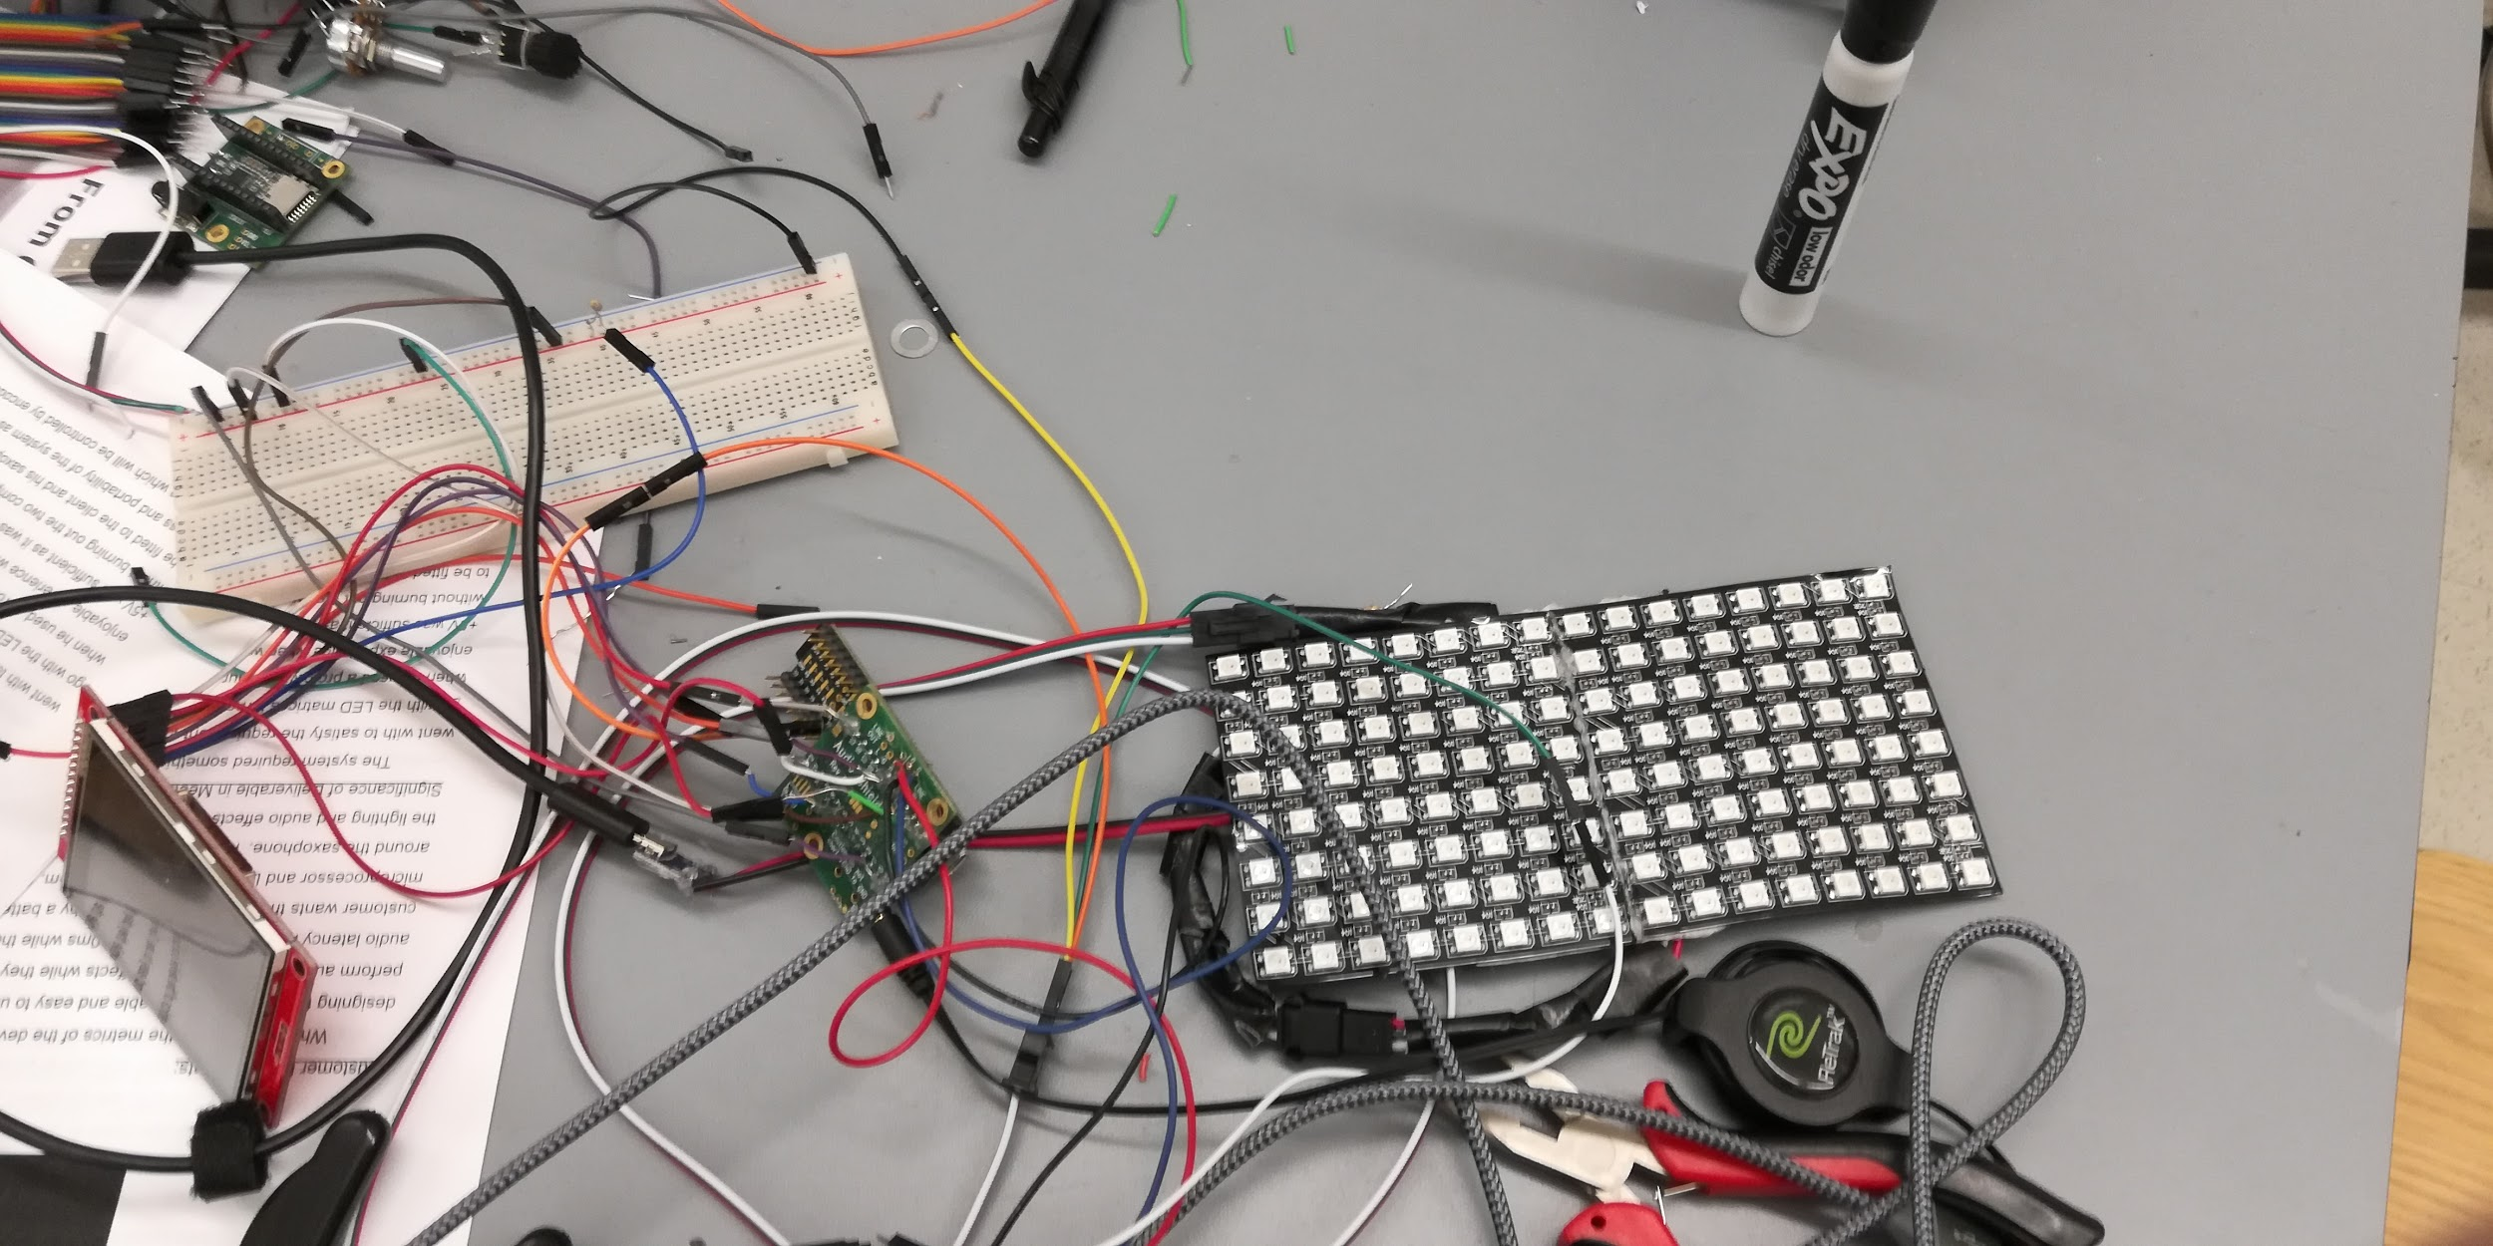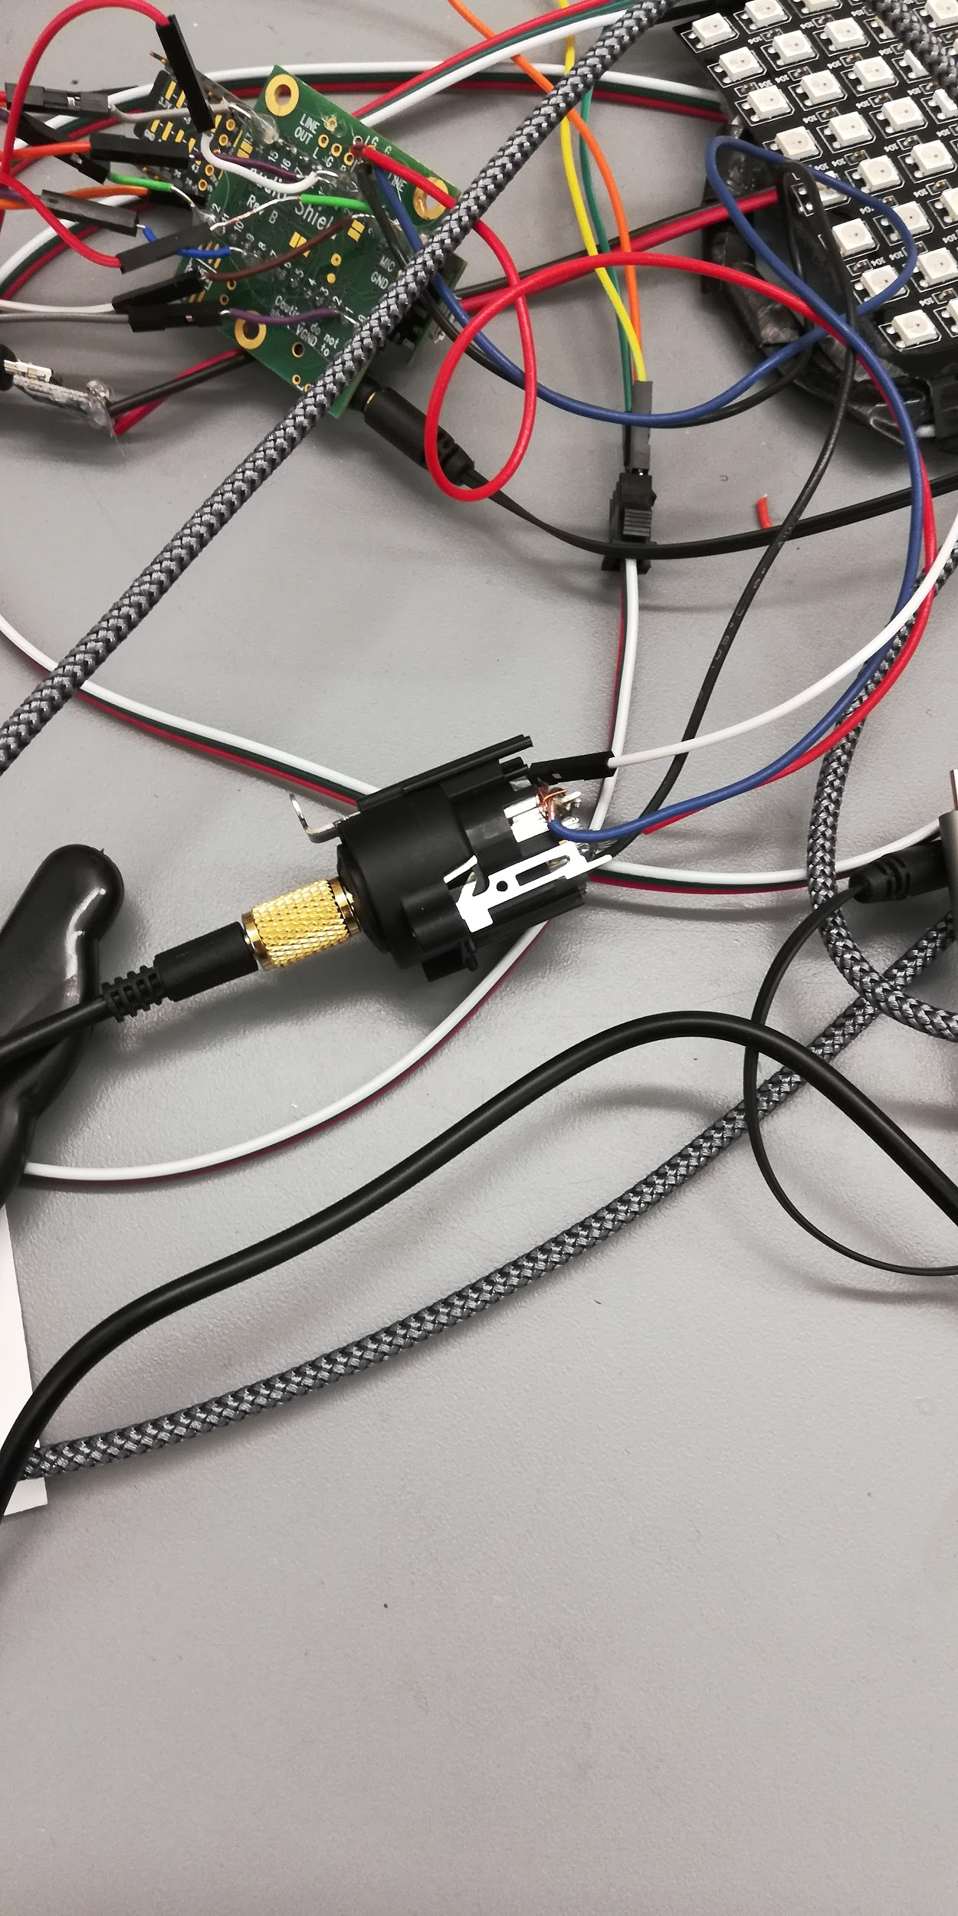

## ***2.4 Installation, setup, and support***

The CyborgSax, LED Matrices, Microphone, and Battery Pack will be provided to the client. Using intuitively-based wiring schemes, the user will wire everything according to the manual.

The team will listen to feedback about both hardware configuration and UI, and make changes for the final design. CyborgSax will also provide firmware updates to resolve bugs, add features, and refine the code.

# 

# **3 Operation of the Project**

## ***3.1 Operating Mode 1: Normal Operation***

*Normal Operation*

Plug in the 5V (1A) power source to the micro-usb female cable extending from the one of the LED matrices. The LCD screen should power up into its initial startup mode and read “Welcome to Cyborg Sax”

Start-Up: Please wait a few moments for the Teensy to turn on. “Welcome to Cyborg Sax!” should display during this time. Once the screen has switched, turn the 4-position switch to initialize the switch’s position.

*Selecting a Mode*

There are 4 modes for the interface, Sound, Lighting, Playback, and General. To select a mode, utilize the 4-position rotary switch to the left of the LCD screen. From the left-most position to the right, the options are Sound, Lighting, Playback, and General. Under each mode, there are parameters that can be changed using the rotary encoders to the right of the screen.

*Note: Selecting a mode will pause all audio output for approximately 1 second.*

*Changing a Parameter*  
To change a parameter, go to the mode it falls under (ex. for reverb, you would select “Sound Mode” with the rotary switch). Next, utilize the rotary encoder to select a parameter to change. The top-most rotary encoder on the box controls Parameter 1, whereas the bottom-most rotary encoder on the box controls Parameter 2. Once you have found the parameter you would like to change, press the respective rotary encoder in once. This will select the parameter as active, and turning the encoder will change the value of the parameter. Once the desired parameter state has been met, simply press the respective encoder again to enter in your new parameter value.

*Note: Selecting a parameter will cause the FFT LED Matrix to freeze until the parameter value is entered and the parameter is no longer affected.*

*Gain:*

There is a stiff rotary knob on the back of the CyborgSax enclosure. This controls your analog output gain of either the XLR port or Aux port.

## ***3.2 Operating Mode 2: Abnormal Operations***

## Abnormal Mode: Plugging in power to the Teensy’s micro-USB - always use a 5V supply. See above (3.1.1) for how to use the user interface.

## Note: Plugging into the Teensy’s USB port provides less power to the to the matrix than if the matrix were powered, thus the standard green, yellow, red spectrum is recommended in order to not overload the current regulator in the Teensy.

## 

## ***3.3 Safety Issues***

* Do not connect both the box’s micro-usb port and the LED matrix’s micro-usb port at the same time.
* Avoid liquids

# 

# 

# **4 Technical Background**

The hardware used involves a Teensy 3.6 from PJRC, a Teensy audio shield, a TFT screen, two rotary encoders, one 4-position rotary switch, one 25k potentiometer, a protoboard for grounding, and a JST 3-pin cable to attach the matrices to the Teensy.

The Teensy 3.6 was chosen due to its processing capabilities and its intuitive audio firmware platform. The Teensy 3.6 is attached to the audio shield and is used to process the input of this audio shield, as well as run the audio through an FFT algorithm (172Hz resolution), which is then processed by our own visualization algorithm, and sent to the LED matrices to be displayed as a spectrum analyzer. The Teensy 3.6 is also connected to the TFT screen, rotary encoder & rotary switch to display and control the user interface and parameters, respectively. These parameters involve sound (volume, effects), lighting (gain, color scheme), playback (TBD), and general (Aux Out/XLR out). The 25k potentiometer is attached to the audio shields potentiometer port in order to control the analog output volume of the CyborgSax product.

The licensing and ownership of this product belongs to our client Zach Lasiuk as he was the one to come up with the idea for this project.

# 

# 

# 

# 

# **5 Cost Breakdown**

|  |  |  |  |  |
| --- | --- | --- | --- | --- |
| Project Costs for Production of Beta Version (Next Unit after Prototype) | | | | |
| Item | Quantity | Description | Unit Cost | Extended Cost |
| 1 | 1 | Teensy 3.6, Audio Shield, and TFT Screen (PJRC) | $66.00 | $66 |
| 2 | 2 | Arduino Rotary Encoder | $4.95 | $9.90 |
| 3 | 1 | Potentiometer | $10 | $10 |
| 4 | 1 | Switch | $9.95 | $9.95 |
| 5 | 2 | LED Matrix | $14.99 | $29.98 |
| Beta Version-Total Cost | | | | $125.83 |

# 

# **6 Appendices**

## ***6.1 Appendix A - Specifications***

Team #7

Project Name: Cyborg Sax

|  |  |
| --- | --- |
| **Specification** | **Value, range, tolerance, units,type** |
| Power | 5 Volt battery pack with ability to output 2.2 amps of current |
| LED Size | Able to fit on the front of sax (max 2 8x8 LED matrices) |
| Audio Delay | No more than 10 ms |
| Controlling Knobs | 2 digital rotary encoders, analogue potentiometer (25k ohms) |
| Switches | 4 position rotary switch |
| Screen | TFT LCD screen (2.8 inch) |
| Microphone Input | XLR/TRS |

## 

## 

## 

## 

## 

## 

## 

## ***6.2 Appendix B – Team Information***

Raymond Liang is currently a senior studying electrical engineering. He was born and raised in Sydney Australia and came to America to complete his university degree. With a passion for engineering and business, he plans to work as a sales engineer after graduation and plans to get an MBA after a few years of industry experience. His hobbies include watching YouTube, listening to music, playing basketball and travelling to different places.

Andrew Zannetos is a junior studying electrical engineering at Boston University - he is a DJ, music producer, and an aspiring acoustics engineer. His passion for music started in 8th grade, when he began using Garageband to produce beats. Now, Andrew produces remixes for top DJ subscription services such as DJCity and BPMSupreme. His DJ career has lead him to play at venues such as Middle East Nightclub, Royale, and House of Blues Boston. He plans to continue his work with EAW over the summer, one of the top loudspeaker designers, as he did last summer as an engineering technician - and with an added role of product manager assistant.

Kevin Yu is currently is a senior studying computer engineering. He was born in Hong Kong, China. He is very passionate about Internet of Things (IoT). He is also interested in cross-border business. He plans to start off his career as an operational consultant in UBS in the fall. His startup G2i cross-border accelerator, a platform to connect ventures to investors and suppliers oversea, has been doing well over the past two years, and he planned to expand the business to Japan later in the year.

Esiri Madagwa Jr. is a senior studying electrical engineering at Boston University. He hails from Long Island, New York. He has always been into music, as he’s been involved with many choirs and musical theatre productions. Theatre is a passion of his, being involving in many shows including Hairspray, American Idiot, and recently, Assassins. He also has a start up company centered around music. His company Pangissimo provides unique portable speakers with surround sound. He plans to make a major career trajectory shift away from engineering and is looking for jobs in the customer service or administrative industry. He plans to work for a year before applying for MFA Acting programs.

Tariq is a senior studying Computer Engineering. After graduating he will be working at a pharmaceutical company in Cambridge called Takeda as a network engineer. While at BU he was a part of an acapella team called Suno and has been on for 4 years.

**From left to right Qinglang Yu,Raymond Liang, Tariq Ahsan,Andrew Zannetos,Esiri Madagwa Jr.**

